JavaScript Algorithms and Data Structures Masterclass

# Section 28: Dijkstra’s Algorithm

## Intro

* This algorithm finds the shortest path between two vertices on a graph
  + **Uses**:
    - 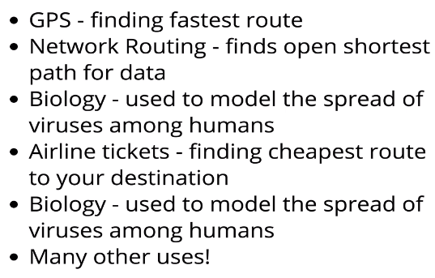

## Walk-through

* **Example**: *Find shortest path from A to E*
  + 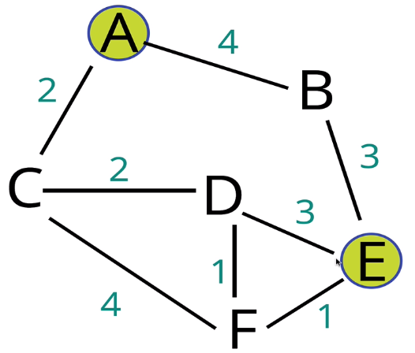
* **The Approach**
  + 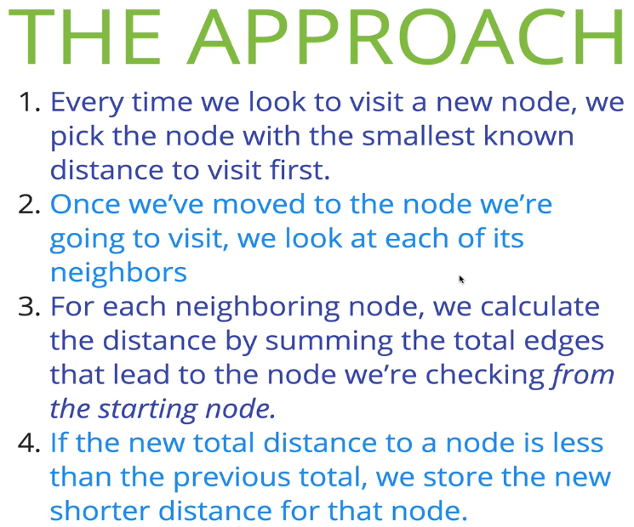
* **Initial Object**
  + 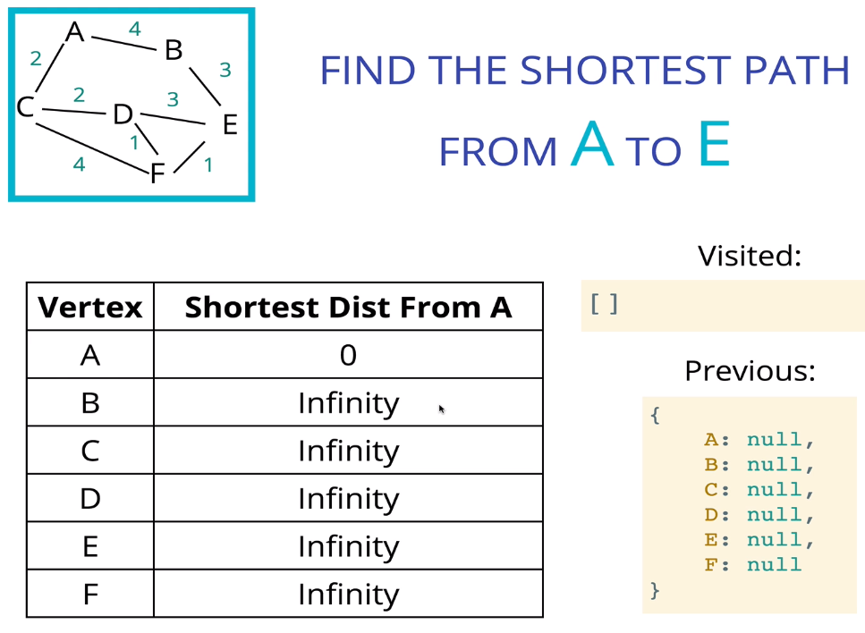
* **Psuedo-code**:
  + 